JEREMY’s treasure hunt | MEDIA KIT FOR JEREMY’s TREASURE HUNT  “When I left you guys after school today, I went to the library to do some research on ol’ Mr. Blackbeard. He was a monster—pure evil. He stole a huge fortune from all the ships he raided and sank. History says that a lot of his loot was never found.” (Jeremy to his friends – Mort and Fiona)  By Sandra L. Bell / Illustrations by Nastassia Mkrtychan

ABOUT THE BOOK:

Jeremy’s Treasure Hunt – by Sandra L. Bell / Illustrations by Nastassia Mkrtychan

LOGLINES: - In a far-off world, not much different than ours, mice face the everyday challenges of life.
-In a world filled with mice, what could possibly go wrong?
-How far would you go for something you believe in?
-How far would you go to be a hero?
-broken promises run deep when they effect kids goals.
-Don’t under estimate kid power.

Jeremy’s Treasure Hunt invites readers into a magical mice world, where ten-year-old mouse Jeremy Jones attends Shady Tree Elementary. Winning the local, school soccer championship has been a dream come true for Jeremy! So, when his school announces its soccer team—despite months of hard work and training—is unable to participate in the regional championships because of a lack of funds, Jeremy decides to raise the money they need. He is determined to do all he can to play that championship game.
When roving pirates complicate his fundraising efforts, young Jeremy and two brave teammates—Fiona O’Malley and Mortimer Gustafson—must embark on a thrilling and sometimes terrifying adventure in search of the pirates’ gold. Along the way, they’ll encounter poisonous snakes, rumbling mountains, collapsing trails, and deadly mirror-mazes. And even if they can triumph through these trials, they’ll have to battle Blackbeard, the most notorious pirate of all time.
Jeremy might have taken on more than he bargained for. Will his team get to the Regionals—and will he, Fiona, and Mort even survive to play in the game?

JEREMY’S TREASURE HUNT – PRESS RELEASE:

PRESS RELEASE
FOR IMMEDIATE RELEASE:

BROKEN PROMISES LEAD TO A DANGEROUS ADVENTURE?
Canadian author uses real life children’s experiences to bring her storytelling adventure to life.
[ST. CATHARINES, ONTARIO – 1/13/2022 – Officially Published] From spending countless hours creating, organising, and implementing interactive adventurous birthday parties for her kids and their friends, Sandra L. Bell has now taken her creative ideas of adventure and intrigue and channelled that into her first children’s book. We all have memories with our families that have helped shape who we are. Sandra’s love as a mother and her ability to connect with children in a positive and warm way, has helped her create a story that young kids and middle-graders will enjoy and embrace as they face the everyday obstacles of being a kid. What originally started as an eighteen page short story in rhyme, has now evolved into the first book of Sandra’s children’s series, Jeremy’s Treasure Hunt.

Jeremy’s Treasure Hunt invites readers into a magical mice world, where ten-year-old mouse Jeremy Jones attends Shady Tree Elementary. Winning the local, school soccer championship has been a dream come true for Jeremy! So, when his school announces its soccer team—despite months of hard work and training—is unable to participate in the regional championships because of a lack of funds, Jeremy decides to raise the money they need. He is determined to do all he can to play that championship game.

About the Author:
Sandra L. Bell used to love to throw adventurous birthday parties for her sons when they were little. One of the best was a dinosaur treasure hunt that thrilled all the party guests. The kids loved the adventure and Sandra loved seeing the excited expressions on their faces. This led the author to write a sixteen-page manuscript that ended up pushed into the back of a drawer. When her grown-up son found it years later, he encouraged her to develop it into a children’s book.
Sandra lives in St. Catharines, Ontario, with her husband and two sons. A recent addition is their son's Maltese puppy, Rocky, with whom the whole family has fallen in love.

Contact
SANDRA L. BELL
PHONE NUMBER: 905-708-2874
WEBSITE: www.theadventuresofjeremyjones.com

Contact
SEAN BELL – MARKETING MANAGER
PHONE NUMBER: 905-941-3061
EMAIL: managerseanbell@gmail.com
WEBSITE: www.theadventuresofjeremyjones.com

LINKS TO MEDIA TRAILERS:

In association with Friesen Press, we have developed two teaser trailers that preview Jeremy’s Treasure Hunt. Please used the links below to view the trailers.

– Coming Soon Trailer: https://youtu.be/BYDjWE5sl5s

– Available Now Trailer: https://youtu.be/4LtV65o-cnU

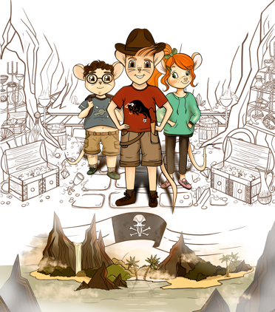

ABOUT THE AUTHOR & ILLUSTRATOR:

Sandra L. Bell used to love to throw adventurous birthday parties for her sons when they were little. One of the best was a dinosaur treasure hunt that thrilled all the party guests. The kids loved the adventure and Sandra loved seeing the excited expressions on their faces. This led the author to write a sixteen-page
manuscript that ended up pushed into the back of a drawer. When her grown-up son found it years later, he encouraged her to develop it into a children’s book.
Sandra lives in St. Catharines, Ontario, with her husband and two sons. A recent addition is their son's Maltese puppy, Rocky, with whom the whole family has fallen in love.

From Sandra:
“My love of children and my ability to connect with them in a positive and warm way, has helped me create a story that young children and middle-graders will enjoy and embrace as they face the everyday obstacles of being a kid”.

Nastassia Mkrtychan is from Belarus and started drawing from a very young age. As well as drawing in school, she attended additional drawing lessons that helped sharpen her skillset. She has always enjoyed fantasizing and visualizing different ideas using her imagination. By the end of school, Nastassia was more interested in technical things, so she entered to become an architect. As time went on, designing buildings did not give her the same pleasure and self-realization as drawing freely. In this direction, she could not develop all her ideas creatively and instead, began to put all her strength into developing herself into an artist. Furthermore, her education greatly influenced her work and helped put her on the path she continues today. Nastassia’s passion is working on illustrations for books, games and albums. Her process involves the author of the work sharing his/her vision of the invented world. As an artist, she helps to embody its atmosphere and using her imagination and creative skills brings that vision to life.

From Nastassia:
“I am very glad when my vision complements the world of the author and other people can most fully plunge into the atmosphere of the work. This inspires me to new work”

AUTHOR QUESTIONS AND ANSWERS:

How did this project Start?
It started by creating adventitious birthday parties for my children and their friends. Treasure hunts were always a popular theme. Kids love adventure, so creating themed based parties brought a lot of joy to

everyone involved. The character of Jeremy was based on my eldest son because he was always wide-eyed for adventure. The original version started out as a rhyme picture book for 4-6 year olds.

Where did you get the idea for this book?

The idea came from a treasured hunt themed birthday party where all the kids thoroughly enjoyed. Inserting lifelike props into the parties made a magical world come to life.

What traits and other tidbits did your eldest son share with your main character?

Originally, the character of Jeremy was based off my eldest son. As the story evolved and I now had two sons, I incorporated traits from both of them into Jeremy. Jeremy is adventurous, rash, hot headed, but has a strong sense of fair play and is very loyal.

Did any of your inspiration for this book originate in your real-life experiences?

The original picture book was written after my first son was born and I was broken hearted to have to leave him to go back to work. I saw how he enjoyed adventure picture books and tried to write a story that not only would he enjoy, but, if I had a success, it meant I could be a stay home Mom.

Are there any specific authors whose writing styles or subject matter inspired your book?

I was always inspired by the Golden picture books, primarily Disney themed. I like happily ever after stories. The final product matured into a more serious good VS evil story.

Do you have another project in the works? If so, what is it?

I do have ideas for a second and third book and would love to share them with the world. This all depends on how my first book is received. If there is an audience and fan base for Jeremy, I would love to continue his adventures.

Why did you Self Publish and when you self-publish, do you do it all yourself?

If you are not an established author, it’s very difficult to get traditionally published. I chose the Self-Publishing route, but, with an experienced company where I could lean count on their expertise. It was a step-by-step process of where I had the final say in what was created.

CHARACTER SNEAK PEAK:

***The main character is Jeremy Jones, pictured in the center. His two best friends, Fiona O’Malley, and Mortimer Gustafson. This Illustration will be featured on the Hardcover and Softcover editions, as well as the eBook.

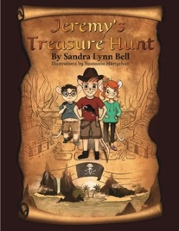
Front Cover Illustration.

MARKETING PLAN:
Overall Strategy: St. Catharines is home to the author of the book and is located right in the middle of the golden horseshoe. Niagara Falls and Niagara on The Lake present a unique opportunity. With visitors numbering in the millions each year to this region, a superb opportunity exists. As well as Consignment opportunities in small gift and book shops, we will also have the book available in the Children’s section of Chapters and Coles. When Author signings return, we will be setting up these events with different venues. Awareness is the ultimate goal and we will accomplish this through online social media adverting, as well as, radio, podcast and TV opportunities.
Target Audience:

A note on the interest groups in Niagara: Sandra has a connection with a number of locals and businesses in Niagara and has established a history with this region and is comfortable establishing contact and a live presence to pitch and present the book. This will help to build the brand locally. Unique businesses in Niagara offer a great opportunity.

Competition: Children’s books and picture books. Sandra’s book offers a hybrid style approach which features a in depth story that young children can read but may ask their parents for a further explanation. Detailed pictures help bring Sandra’s vision of her characters and world of story to life.

Bookstores: The Old Niagara Bookshop on Regent Street in Niagara-on-the-Lake is a regional focal point for the sale of printed copies in Niagara on the Lake. Sandra will also be approaching other Niagara Region bookstores and unique gift shops, (FORGET ME NOT) and will host book signings and other events as needed. These will be done a consignment basis. (Chapters/Indigo will be approached when the book is available)

Book launch: a book launch is in the works when Covid Restrictions allow in St. Catharines.

Media kit: This media kit will be made available to radio, TV, and printed media outlets.

Online presence: a solid online presence is planned: the website (already launched), Facebook, Twitter, Goodreads, and others. As well, Social Media Advertising is planned to extend the reach outward as awareness and readership picks up.

ORDERING INFORMATION:

Book Details:
95 pages
Size of the book: 9 inches X 11 inches

ISBNs:
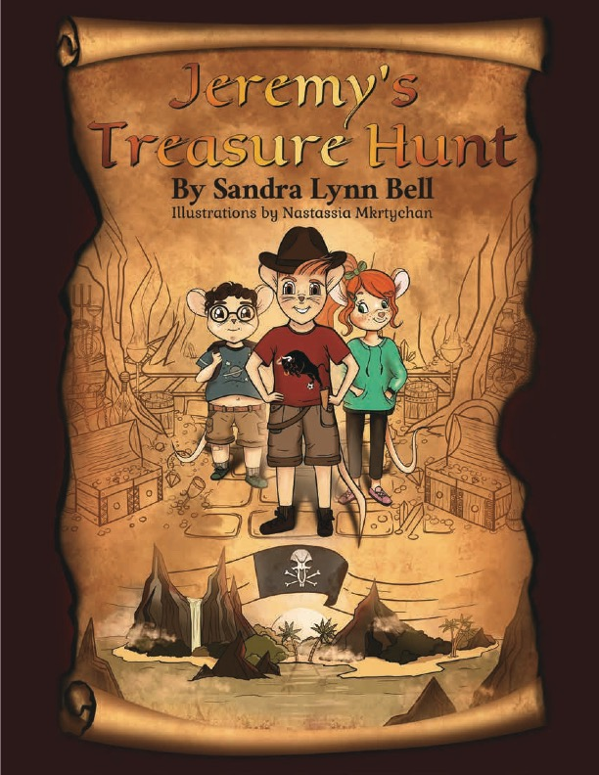
978-1-5255-7762-8 Hardcover
978-1-5255-7763-5 Paperback
987-1-5255-7764-2 eBook

Categories:
Adventure, Problem Solving,
Learning, Treasure Hunt, Buried Treasure,
Juvenile Fiction, Mice Kids

Keywords:
Kids Pirate Books, Animal Adventures, Soccer Stories, Treasure Hunts, Pirate Gold, Pirate Adventure, Mouse Stories

FriesenPress Bookstore Prices:
Paperback: $22.99
Hardcover: $35.49
eBook: $5.99
Retailer prices will vary, depending on currency exchange rates and store policies. As well, consignment prices are done on a store-by-store basis.

Available at the following outlets:

In Bookstores/Giftshops: Coming Soon

Online Paperback & Hardcover:

FriesenPress Bookstore
Amazon.ca
Amazon.com
Barnes&Noble.com
Apple Books
KOBO
Google Play

